INTRODUCTION

Curriculum Resource Guide

Academy of Graphic Arts

Christina L. Smith

July 13, 2007
EVT 6948-Practicum Indust/Tech Ed

Summer ‘07

TOPIC
I have created a curriculum resource guide for our new Academy of Graphic Arts. The curriculum resource guide integrates the Digital Design 1 course curriculum of the Digital Design Florida State adopted program with the Language Arts coursework for English 2, 10th grade students. As the teacher of this course and the Program Director of the Academy of Graphic Design, it is imperative that we create lessons or projects that demonstrate and document this type of cross curriculum integration and to be consistent with the National Best Practices for Academies. In order for it to be a true Academy there needs to be a documented correlation of standards and lessons (NABP). The course and program is not new to Chiefland High School, whereas the Academy is new and will start in the Fall of 2007.
NEED
The need in creating an Academy and an Academy of Graphic Design Curriculum Guide is a result of High School Reform. It includes and combines Carl Perkins (http://www.fldoe.org/workforce/plan_perkins.asp), No Child Left Behind (http://www.flsenate.gov), Just Read Florida (http://www.justreadflorida.org/), A++ Implementation (http://www.fldoe.org/APlusPlus/), Workforce Education (http://www.fldoe.org/workforce/) , Continuous Improvement Model (http://www.bsi.fsu.edu/schoolimprove/cim.htm), School within a School (http://www.fldoe.org/workforce/careeracademies/ca_models.asp), Career Academies (http://www.fldoe.org/workforce/careeracademies/ca_reform.asp), Career Academy National Best Practices (http://hsalliance.org/_downloads/home/Career_Academy_National _Standards_of_Practice.pdf) and the Florida Curriculum Frameworks for Digital Design (Digital Design) and 10th grade Sunshine State Standards for Language Arts (English 2). Career Academies are one of the several school-to-work initiatives under the School-to-Work Opportunities act of 1994.
With this need to increase standards among our high schools there comes a need for financial assistance through an Innovative Fair Matchmaker Grant (http://www.fldoe.org/flbpso/otherpubschopt/innovationfair.asp) and then followed by the Succeed Grant (http://www.fldoe.org/workforce/dwdgrants/2007/succeed07.asp) to make this new reform feasible for all schools.
SETTING
Chiefland High School in located in the heart of Levy County, Florida. Our student population is 540 students. Student population mirrors the community: 81.1% White, 14.2% Black, 2.4% Hispanic, 9% Asian, .4% Multiracial. Grade enrollment is 157-Grade 9, 156-Grade 10, 129-Grade 11, 98-Grade 12. Our staff consists of consist of 5 administrators, 7 support staff, and 30 teachers with a teacher-to-student ratio 21:5. Our program targets high students 9th through 12th grade. The following is the FLDOE Digital Design program structure:
Computing for College and Careers-Information Technology Assistant
Digital Design 1-Production Assistant
Digital Design 2/Digital Design 3-Digital Assistant Designer
Digital Design 4/Digital Design 5-Graphic Designer
Digital Design 6/Digital Design 7-Media Designer

Current student enrollment is 175 students. That is 32% of our students are enrolled in our program and more than 50% of our 9th graders are enrolled for the fall of 2007. The numbers have declined as coursework becomes more rigorous in academic courses, the limited amount of class periods to take the continued program, and FCAT remediation programs. The Academic structure and graduation requirements limit how many students are able to take this program. The Academy will be benefiting from student increase in CTE participation as part of its National Standards of Practice and 9th graders having to declare a major.
PUPOSE
The need for an Academy of Graphic Design Curriculum Resource Guide comes about with the purpose to help teachers integrate curriculum and meet the needs of High School Reform. It provides the tools needed in creating projects with the ease of a template using a database of the Curriculum Frameworks of Digital Design I and English 2. I have also included a database of the Sunshine State Standards for the majority of the 10th graders taking Life Management Skills, World History, Visual Arts, Algebra 1B, and Biology. I created a template that will include all the database of subject standards as well as Objectives, Reading Strategies, Bloom’s Taxonomy, and Learning Styles. The Curriculum Resource Guide is the ultimate integration of total High School Reform and designed at making Chiefland High School a better high school where students will want to learn more.
James J. Kemple and Jason C. Snipes wrote “Career Academy Impacts for Students at High Risk of Dropping Out”, they state “Career Academies attempt to create more supportive and personalized learning environments through a school-within-a-school structure. Their curricula combine academic and occupation-related course requirements that aim both to promote applied learning and to satisfy college entrance requirements. Academies establish partnerships with local employers to build sequences of career awareness and work-based learning opportunities for their students.” The purpose of the program is to do just that. The purpose of the Digital Design program was chosen based on student interest and workplace skills needed.
The research is relevant to the new school reform of adding Career Academies. The need is to integrate curriculum is part of this reform. The need is for rigor, relevance, and relationship within all coursework. I believe CTE courses do this, but the academic department needs to understand how their courses should correlate with these real world skills that we are teaching. Students need to understand that all academic classes tie in with CTE courses and real word skills.
IMPLEMENTATION
With creating an Academy of Graphic Design the National Best Practices (http://www.fldoe.org/workforce/careeracademies/ca_standards.asp) outlines the steps to do this. The steps include:
- Defined Mission and Goals
- Academy Structure
- Host District and High School
- Faculty and Staff
- Professional Development
- Governance and Leadership
- Curriculum and Instruction
- Employer, Higher Education and Community Involvement
- Student Assessment
- Cycle of Improvement
The implementation of our Academy has been fairly flawless I will have to say. We have had a great response by students, faculty, and local community business members. The only complication that we have run into is the scheduling of students in creating a Cohort of a small learning community based on the academic and remediation classes that students must take as well. This process will be challenging in the upcoming year.
In the process of developing a Curriculum Resource Guide I have also created an Academy Resource Guide for our High School Academy Team and our Academy Advisory Board, along with a web page that promotes our Academy of Graphic Design located at http://www.levy.k12.fl.us/schools/chs/AcademyofGraphicArts/index.htm. Enclosed are also three articles written in the local Chiefland Citizen newspaper regarding our new programs (See Appendix A, B, and C). I also had the great opportunity to speak to the Chiefland Chamber of Commerce in getting more local business enthusiastic about creating an Academy that can benefit everyone. Promoting programs is a key to implementation.

APPENDIX A
Chiefland Citizen, CHS Academic Board Created, January 2007
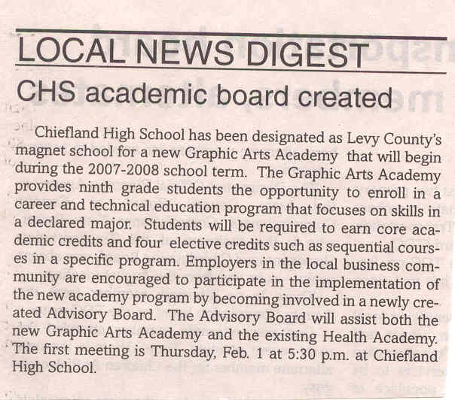

APPENDIX B
Chiefland Citizen, Business Leaders Wanted, Thursday, June 7, 2007
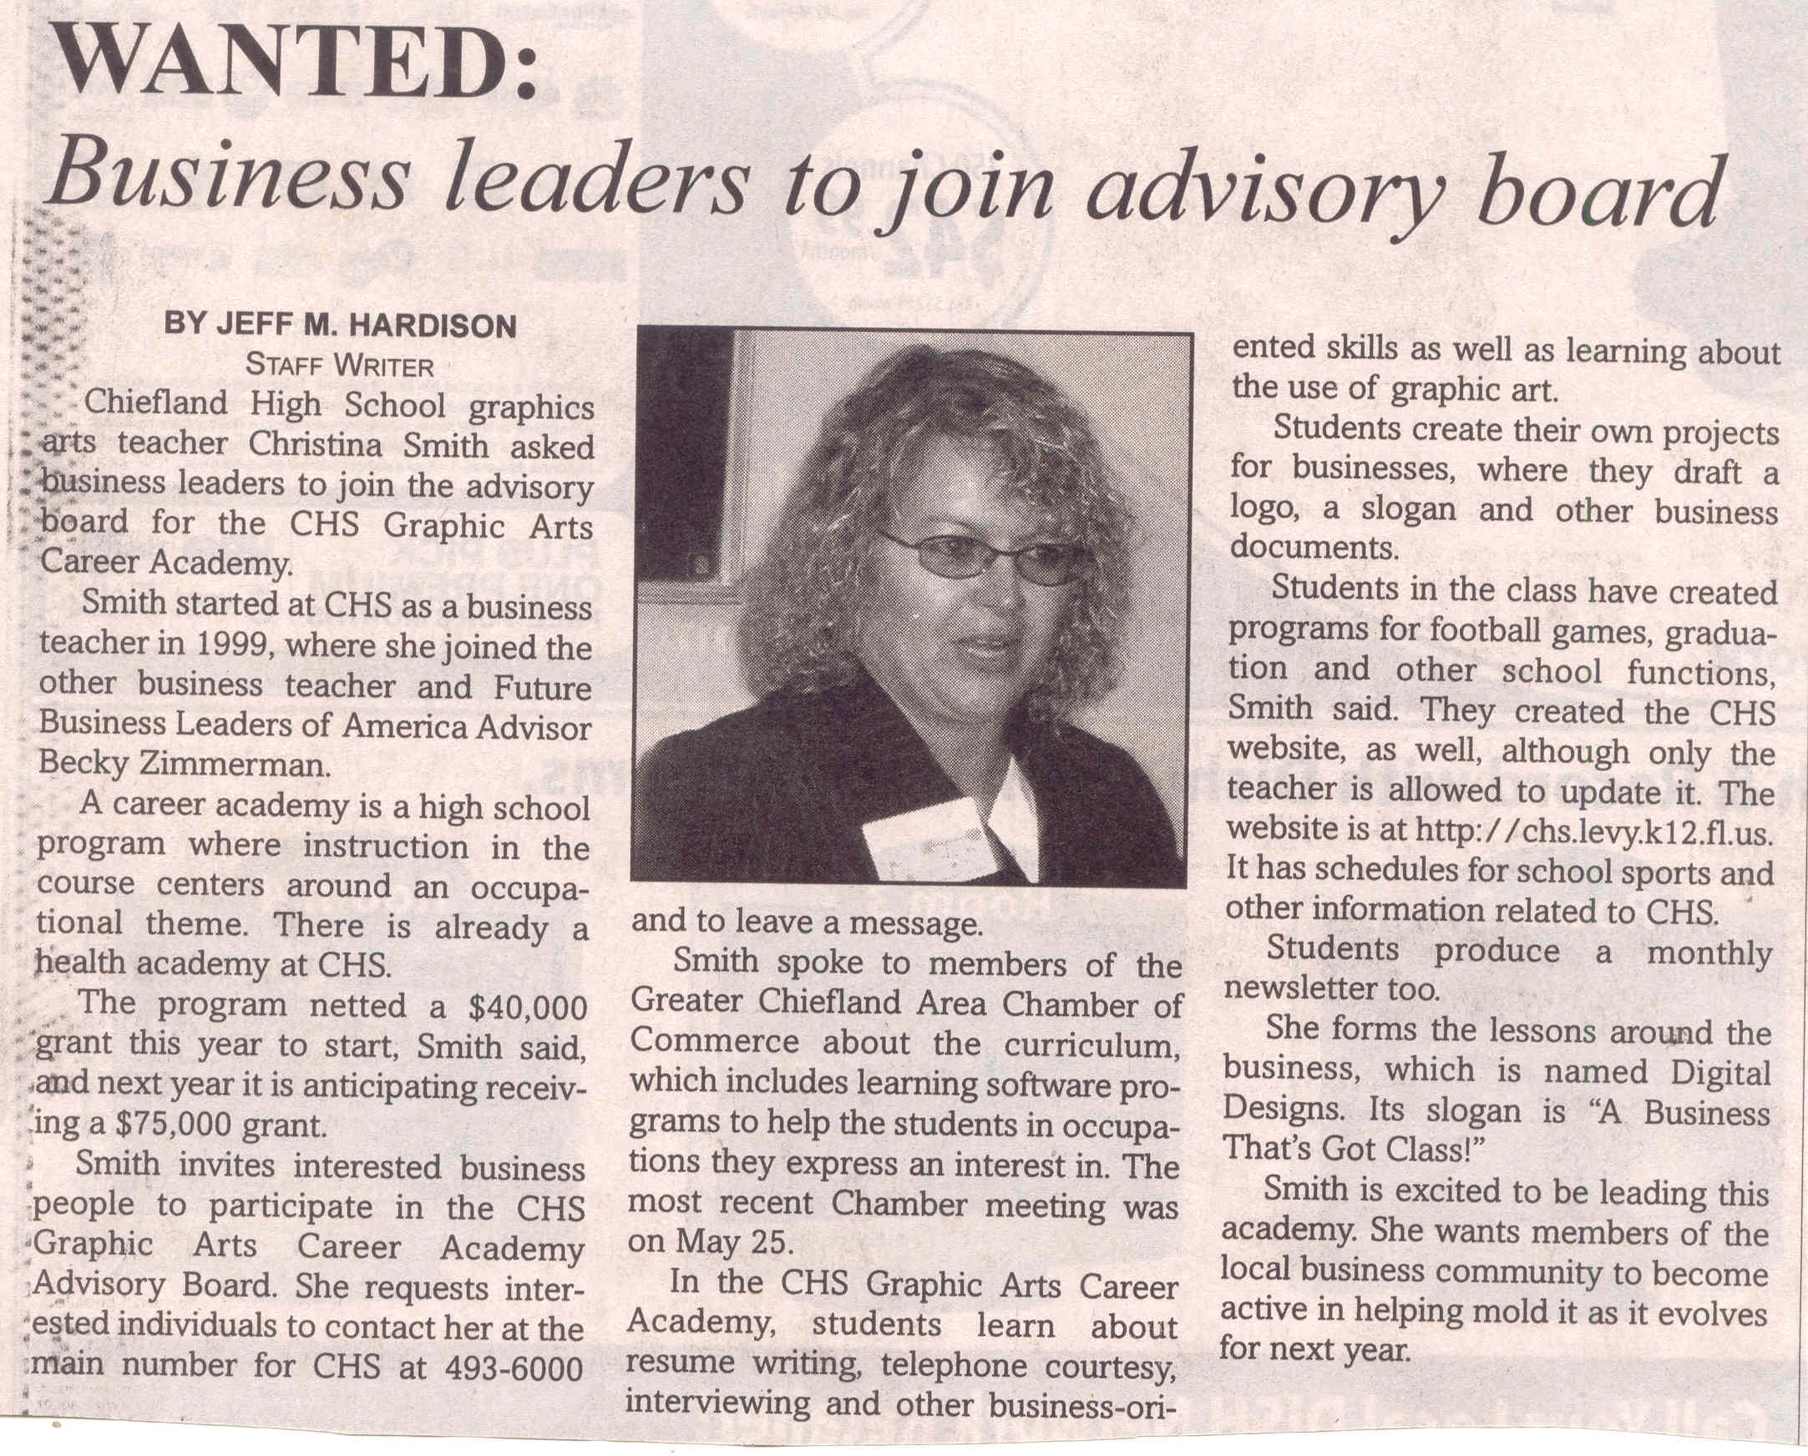

APPENDIX C
Chiefland Citizen, CHS Academy Board Means Business, Thursday, June 7, 2007
