Conceptualization and Development

Curriculum Resource Guide

Academy of Graphic Design

Christina L. Smith

July 13, 2007
EVT 6948-Practicum Indust/Tech Ed

Summer ‘07

CONCEPTUALIZATION
My vision of a Career Academy started seven years ago when I developed the Digital Design Program at Chiefland High School. I established criteria for students of the program to progressively learn and apply software and business application that would be used in the third year of the program. The criteria I established was to develop a Business Plan and Handbook located at in creating a business called Digital Design, “A Business That’s Got Class!” (See http://www.levy.k12.fl.us/schools/chs/AcademyofGraphicArts/Digital%20DesignHandbook.htm) My vision included teaching real world skills to better prepare our students. This concept I felt was to integrate other subjects, school improvement, and to help local community businesses with the use of technology. I designed projects that motivated students to better improve themselves, the school, and our community. In improving themselves students were able to concentrate on their own careers with the use of technology and to become self-directed learning students.
In creating our new Career Academy I felt that we should use our current student enrollment and interest in continuing with our already existing Digital Design program, therefore I wanted to create an Academy of Graphic Design. The design is very similar to the Digital Design Program in that the Academy of Graphic Design students are to take the following sequence of courses that include the 9th grade class for Computing for College and Careers, the 10th grade class for Digital Design I, the 11th grade class for Digital Design 2, and the 12th grade class for Digital Design 3. This type of coursework allows the student to be Occupational Completers and qualify for the Gold Seal Scholarship. Current enrollment of the program over the years is has grown based on student trends and interest in technology that is offered. (See Appendix A).
Another reason for my decision in creating an Academy of Graphic Arts was based on future Labor Market Trends (See Appendix B) and the increase in student’s knowledge of technology in many areas of industry related to their interest. It is sighted that one of the top five key working skills needed by our young adult workforce was the use of technology (Career Pathways: Education with a Purpose, page 16).
There are many factors that are a benefit of having a Career Academy. One factor of having Career Academies requires national industry certifications; this is a very positive benefit for students and today’s workforce. Students should feel as if they have a goal other than obtaining just a credit for graduation. Another factor would be the makeup of a cohort and the volunteer efforts of the students being part of an Academy.
As Program Director for our new Academy of Graphic Design I had to prove my concept and convince my Coordinator of Career and Technical Education and my Principal that this was the Academy for Chiefland High School. We all had different ideas on what should be offered at Chiefland High School. The final decision came from my Principal based on employment trends and the amount of students enrolled in the Academy that was represented by a diversified number of males. Currently males represent 40% and females represent 60% of the students enrolled. It meets the needs of establishing an Academy of Graphic Design for Chiefland High School.
DEVELOPMENT
In the development of our new Academy of Graphic Design, I created a Resource Guide that included many of my concepts. You can follow the link from our Chiefland High School website (http://www.levy.k12.fl.us/schools/chs/AcademyofGraphicArts/index.htm) to view them. This was the first step in helping teachers, administration, and our new Academy Advisory Board in visualizing the affects and benefits of our new Academy of Graphic Design.
The next step was to invite local business leaders, administration, teachers, and students to become part of our Academy Advisory Board. The board will provide additional concepts and benefits to our current Health Academy and our newly formed Academy of Graphic Design. The district Coordinator of Career and Technical Education has helped me a great deal in establishing a list of potential members, along with writing and mailing each personal letter inviting them to attend (See Appendix C). The response was great, but the first meeting held on February 1, 2007 did not include many members due to other obligations and the stormy weather. We have since had meetings held on March 6, April 19, and June 5 (See Appendix’s D-I for agendas and minutes that I had available.)
Although I provided a resource guide in establishing our Academies, it was known that the Academy Advisory Board would make changes as part of the National Best Practices stating that an academy is to have a governing structure that incorporates the views of all stakeholders as listed below. (National Career Academy Coalition, http://www.ncacinc.org/ncacinc/cwp/view.asp?A=3&Q=259997).
a. Advisory board with broad representation. The advisory board has members from the district and high school administration, academy teaching staff, supporting employers and institutions of higher education. It may also include community representatives, and academy parents and students. The board incorporates viewpoints from all members.
b. Regular meetings. Meetings of the board are held at least quarterly, with defined agendas and outcomes. The board helps to set policies for the academy. It also serves as a center of resource development.
c. A healthy partnership. Both through the advisory board and other interactions, there is evidence of a partnership between the Academy/high School and its host community.

d. A student voice. Students have avenues through which they can provide input to the academy policies and practices.

The Academy Advisory Board has so far established a mission statement and is in the process of creating a single student application and teacher recommendation letter that is universal for our Health Academy and Academy of Graphic Design.
As part of establishing enrollment by students in our Academy of Graphic Design and members that make up our Academy Advisory Board, it was important for me to motivate them to have to same desire and enthusiasm to participate. With student enrollment I had to create a brochure and bulletin to represent the benefits of the Career Academy that included learning new and exiting skills of technology and software applications to include self-directed learning activities related to individual career interests. I had to promote my Academy to students. I did this by taking my Digital Design 1 class to the Middle School orientation to High School. I talked about the many exiting opportunities that are available when taking these courses. Applications and teacher recommendation letters were available for students to fill out at their leisure and to discuss their choice of becoming a part of the Academy of Graphic Design with their parents and teachers. I also promoted my program to students by participating in an evening program for parents and students at the 8th grade orientation to High School. I believe my motivation and enthusiasm has carried through to the students and parents to give them the desire, motivation, and enthusiasm to be part of a Career Academy that provides students with tools useful for careers, college, and for work. The same motivation works for getting local businesses, teachers, administration, and teachers to participate in our Academy Advisory Board. I have promoted participation through welcome letters, speaking to our local Chamber of Commerce, and getting the local newspaper involved in publishing articles related to our activities. Our Board also established that lunch meetings were appropriate for providing the most participation. I therefore search for local donations that will provide lunch and door prizes. This strategy of providing a benefit to everyone involved creates another reason to participate in being part of our Academy Advisory Board. Our meetings have been very successful and the support of teachers, administration, parents, students, and local community members. For a true academy to work you must have support. “The Career Academies in this study demonstrate the feasibility of implementing a well-defined and effective approach to creating a more supportive high school environment and increasing students’ exposure to career awareness and work-based learning activities (Career Academies, Impacts on Student Engagement and Performances in High School, http://www.mdrc.org/publications/41/execsum.html).” Schools, partnerships and community support and involvement are a key to making Career Academies work. They describe Academies as being aimed for all students to broaden their knowledge of careers and better prepare students for work and college.
Another step in development of our Academy of Graphic Design that is outlined in the National Best Practices is appropriate teacher selection; leadership, credentialing, and cooperation are critical to an academy’s success (National Career Academy Coalition, http://www.ncacinc.org/ncacinc/cwp/view.asp?A=3&Q=259997).
a. Teacher Leader(s)/Coordinator(s). One teacher (sometimes two) agrees to take the lead, serving as the academy Coordinator(s). This includes attending advisory board meetings, interacting with administrators and board members, managing the budget, helping to coordinate teacher professional development, and helping to coordinate employer, higher education, and parental involvement. Release time and/or a stipend are provided for this role.
b. Teachers are credentialed in their field, volunteer in the academy, and are committed to its mission and goals. Since a career academy’s success rests on good teaching and good teamwork among a cross disciplinary group of teachers, they must be well qualified and willingly involved in this role. They understand and support the philosophy and purpose of the academy, work together as a team, teach a majority of their classes in the academy, and cooperatively share the duties of operating an academy.

c. Counselors, non-academy teachers, and classified staff are supportive. Non-academy staffs are also important to its operation. Counselors understand the need for cohort scheduling and provide this for academy students. Non-academy teachers understand the value of the academy and help in recruiting students for it and providing departmental support. Classified staff helps support the academy facilities, equipment and learning materials.

We have created a faculty and staff team for our Academy of Graphic Design that provides the necessary instructional integrated curriculum that works together in creating the best possible solution for student learning. Our team is made up of two Business teachers, four English teachers, one guidance counselor, our Principal, and our District Coordinator of Career and Technical Education. Along with participation the District has hired a Career Academy Educational Consultant to help in this process. Our team has participated in visiting our mentor school, Buchholz High School in Gainesville, Florida. Our team attended a three-day conference in West Palm Beach and visited several established, working Career Academies. We attended a two-day workshop provided by Educational Consultant to create integrated curriculum projects as a team. The “Career Project” in my curriculum resource guide is one of the projects that were created by our team. In my curriculum resource guide I created a database template that will make future projects and lesson to be created a more organized use of teacher’s valuable time. Other conferences are lined up to continue the professional development of our team to enhance the ongoing needs in starting an Academy that includes all the National Best Practices.
The development of our new Academy must also include our very own Chiefland High School student performance strategies that must be used in our classrooms. These strategies are included, but are not limited to Marzano, Gaddy, and Dean’s identified nine instructional categories that strongly affect student achievement (What works in classroom instruction, http://www.mcrel.org/topics/Instruction/products/110/ ).
- Identifying similarities and differences
- Summarizing and note taking
- Reinforcing effort and providing recognition
- Homework and practice
- Nonlinguistic representations
- Cooperative learning
- Setting goals and providing feedback
- Generating and testing hypotheses
- Activating prior knowledge
With all this in mind we have to take into account every type of High School Reform to make High Schools that work.
The final development that is needed with every Career Academy is having the resources for continued National Best Practices (National Career Academy Coalition, http://www.ncacinc.org/ncacinc/cwp/view.asp?A=3&Q=259997).
Adequate funding, facilities, equipment and materials. District and high school administrative support results in adequate academy funding, facilities, and equipment and learning materials. These reflect a serious commitment from the district and high school to the success of the academy.
With the help of our District Coordinator of Career and Technical Education, she applied and received a Matchmaker Fair Grant of $40,000 for this past year and is currently working on our Succeed Grant for the 2007-2008 school year in the amount of $75,000. Funding of technology, equipment, textbooks, and National Industry Certifications are very important to the growth of creating a National Best Practiced Career Academy for our new Academy of Graphic Design. “The variation among the participating Career Academy highlights the adaptability of the Academy approach to local needs, capacities, and circumstances. Such variation indicates the potential for the Career Academy approach to disseminate more widely (Executive Summary-Career Academies, http://www.mdrc.org/publications/162/execsum.pdf, page 14).
In conclusion, a Career Academy takes careful planning, resources, and the support of everyone to be successful. It is created from High School Reform to conceptualization to development and leads to implementation. The data found in my review of literature documents that Career Academies work. They provide the benefits that were outlined in key findings on a report written by Kemple and Snipes. The report was based on the Manpower Demonstration Research Corporation’s (http://www.mdrc.org/) 10-year Career Academies Evaluation. It focused on nine Career Academies and 1,700 students. The following key findings were concluded in their research (Career Academies, Impacts on Student Engagement and Performances in High School, http://www.mdrc.org/publications/41/execsum.html).

- The Career Academies in this study increased both the level of interpersonal support students experienced during high school and their participation in career awareness and work-based learning activities.

- The Career Academies substantially improved high school outcomes among students at high risk of dropping out. For this group, the Academies reduced dropout rates, improved attendance, increased academic course taking, and increased the likelihood of earning enough credits to graduate on time.

- Among students least likely to drop out of high school, the Career Academies increased the likelihood of graduating on time. The Academies also increased vocational course taking for these students without reducing their likelihood of completing a basic core academic curriculum.

- In sites where the Academies produced particularly dramatic enhancements in the interpersonal support that students received from teachers and peers, the Career Academies reduced dropout rates and improved school engagement for both high-risk and medium-risk subgroups (about 75 percent of the students served). Academies that did not enhance these supports actually increased dropout rates and reduced school engagement for some students.

- The Career Academies did not improve standardized math and reading achievement test scores.

- When the findings are averaged across the diverse groups of students in the full study sample, it appears that the Career Academies produced only slight reductions in dropout rates and modest increases in other measures of school engagement.

Career and Technical Education provides all the benefits to students in giving them competencies to work in the real world. The Academy of Graphic Design implementation will give students the rigor, relevance, and relationships needed to be successful.

APPENDIX A

Current enrollment of the program over the years is has grown based on student trends and interest in technology that is offered.

Levy County

Program completers  35 program completers in 2002-02  53 program completers in 2002-03  99 program completers in 2003-04 | Latest data taken from CTE Improvement 5-step Plan taught by Dr. Hernandez, Occupational Completers in Career and Technical High School Business Education Technology Programs, page 6, April 26, 2007.  Florida Department of Education, FETPIP Reports for Occupational Completers for Levy County,  http://www.fldoe.org, retrieved May 2007.

Found Work
14 program completers in 2002-02
34 program completers in 2002-03
62 program completers in 2003-04

Found employment related to their training
7 program completers in 2001-02
13 program completers in 2002-03
14 program completers in 2003-04

Continued on with their education
12 program completers in 2001-02
24 program completers in 2002-03
57 program completers in 2003-04

Entered the military forces
2 program completers in 2001-02
2 program completers in 2002-03
7 program completers in 2003-04

APPENDIX B
Labor Market Trends

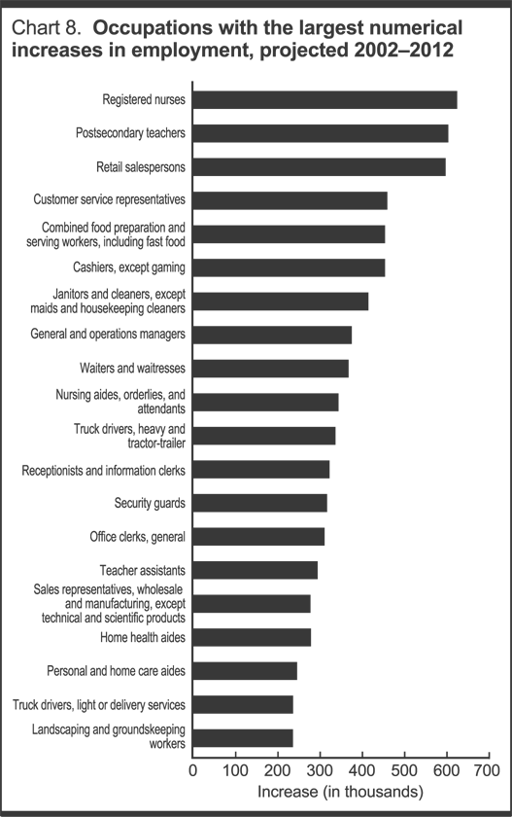
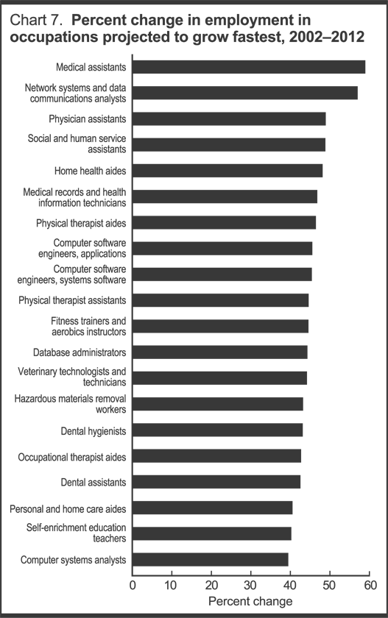

Information taken from CTE Improvement 5-step Plan taught by Dr. Hernandez, Occupational Completers in Career and Technical High School Business Education Technology Programs, page 11, April 26, 2007.

U.S. Department of Labor, Bureau of Labor Statistics-Job Market Trends, http://www.bls.gov/,retrieved February 2007.

APPENDIX C
Letter inviting local business to participate as a member in Chiefland High School Academy Advisory Board.

January 8, 2007

Dear Community Member,

Chiefland High School has recently been awarded a grant by the State of Florida to create a new Academy for our students. Our students live and work in a world full of exciting opportunities; a world that is also more technical and competitive. Their future success depends upon a strong academic foundation and a mastery of technology. A well-rounded education requires the development of other aptitudes and abilities, such as problem solving, critical thinking, communication, leadership, and team-work.

To implement this new Academy, we will need your assistance in establishing curriculum goals, determining the labor demands of our community, and providing valuable information needed to shape the goals and objectives of the program. To that, we are inviting you to serve on a newly created Academy Advisory Board that will assist both the new Academy and the existing Health Academy. Attached you will find a brief description of the purpose of an Advisory Board.

The new A ++ legislation and the reauthorization of the Carl D. Perkins grant have added new requirements for our schools and our students. The goal is for all students to enter high school with a "major area of interest" and opportunities to pursue that major by taking a sequence of courses that will lead to industry certification and/or college credits insuring they will enter the workforce prepared for success. It is critical that our business community members have a voice in the implementation of these new legislative requirements.

The first meeting will be held Thursday, February 1st at 5:30 p.m. in the conference room at Chiefland High School. If you are unable to attend the meeting please send your regrets to Pamela Asbell, Principal. We look forward to our first Academy Advisory Board meeting and the implementation of a new Academy at Chiefland High School. If you have additional questions prior to our meeting, please feel free to contact Pamela Asbell or Christina Smith at 493-6000, or you can email Christina Smith at smithch@levy.k12.fl.us.

Sincerely,

Christina L. Smith
Business Education Instructor

APPENDIX D
Chiefland High School

ACADEMIES ADVISORY BOARD MEETING AGENDA
Date: February 1, 2007 Time: 5:30 p.m.
_________________________________________________________________________

I. CALL TO ORDER/WELCOME…………………………………..……….Christina Smith
A. Introduction of Faculty/Staff and Advisory Board Members

- NEW BUSINESS

  - Overview of Academy
  - Discuss committees
  - Election of Advisory Board Officers
A. Advisory Board Officers: Chairman
Co-Chairman
Secretary
Treasurer
- ACADEMY GOALS FOR 2006-07

  - Projected Budget ………………....
  - Committee Chair confirmation/selection and meeting date for committee
  - Committee confirmation/selection by Board Members (White Board sign-up)
  - Plan of Action—Committee Goals Summary………………...
    - Internship/Mentoring
    - Publicity/Industry Education
    - Fundraising and Scholarship Opportunities

- District Action Items
  - Search for New Program Directors
  - Class Size Amendment
  - Level III Course Approval from DOE Request for Honors Level Credit

- ACADEMY UPDATES………….…….…..…
- Summer Internship Programs
- Professional Development
- Curriculum………………………………………….
- Mentors
Student Travel-FBLA

IV. ANNOUNCEMENTS/COMMENTS/RECOGNITIONS
A. Projected Board Meeting Dates: January and March 2007
- Academies Senior Dinner Date: April
- Career Academy Forum Date: at Chiefland High School
- Academies EXPO – Date

ADJOURNMENT

APPENDIX E
Academy Advisory Board Minutes
February 1, 2007 at 5:30 p.m.
Chiefland High School Media Center

Christina Smith called the meeting to order at 6:45 p.m.
Advisory Board Members that attended:
Faculty
Christina Smith, Program Director and Business Teacher
Becky Zimmerman, FBLA Advisor and Business Teacher
Alice Graham, HOSA Advisor and Health Science Teacher
Pam Asbell, CHS Principal
Students
Brittani Scoggins, HOSA student
Rebekka Wilkerson, Digital Design Student
County Office
Mike Todd, Director of Secondary Education
Carol Jones, Vocational Coordinator
Community Members
Paige Brookins, Levy County School Board member and parent
Leah Carlson, Health Science Teacher
Stacey Wilkerson, parent of Digital Design student

Advisory Board Members that regretfully was unable to attend included Mr. Beauchamp, Mr. Wasson, and Mr. Williams

Christina Smith passed out Advisory Board Academy plan books to all that attended, highlighting many important items related to our Academies. Items discussed were: Career Academies, A++ Legislature, industry standards and skills, Career and Technical Education and programs at Chiefland High School, and described the Health Academy program and manual, along with Academy of Graphic Arts program and manual.

No officers were elected and no committees were formed at this time. We are looking for more members to serve on our Advisory Board.

We discussed how important skills are for our students after graduation and could use input from our Advisory Board of those skills needed and to help our students to enhance those skills.

It was noted that the health field and the computer fields are one of the fastest growing industry skills needed

Becky Zimmerman and her Future Business Leader of America students spoke to the Advisory Board.
Students in attendance were: Shelly, Jamie T., Rebekka Wilkerson, Katherine Bowker, and Jamie Harris.

Alice Graham and her Health Occupations Student Organization students spoke to the Advisory Board,
Students in attendance were: Cherrie T., Jamie T., Matt Bray, and Brittani Scoggins.

Next planned meeting is a luncheon meeting scheduled for March 6 at 11:30. The location was not decided, but Career and Technical Education leaders would find a place complimentary to our meeting.

APPENDIX F
Chiefland High School

ACADEMIES ADVISORY BOARD MEETING
Date: March 6, 2007 Time: 11:30 a.m.
_________________________________________________________________________

I. CALL TO ORDER/WELCOME…………………………………..……….Christina Smith

A. Introduction of Faculty/Staff and Advisory Board Members
B. Thank you Capital City for hosting our Advisory Board Meeting
C. Chiefland High School Calendar

II. OLD BUSINESS… ………………………………..……….Christina Smith
Review of February 1, 2007 Advisory Board Meeting Minutes

- NEW BUSINESS……………………………… Carol Jones

  - Academy NEWS
    - Workplace Skills
    - HOT and COLD Jobs

  - Discuss committees-
    - Application process
    - Marketing/Recruiting
    - Curriculum

  - Election of Advisory Board Officers
A. Advisory Board Officers: Chairman
Co-Chairman
Secretary
Treasurer

III. ANNOUNCEMENTS/COMMENTS/RECOGNITIONS

A. Projected Board Meeting Dates: Best days and times of the Week?
- Business Affair Presentation by CHS Business Students-projected date March 29, 2007, April 19 or 26, 2007.
- Best Buy $2500 Grant was awarded to Christina Smith’s Digital Design class.

IV. ADJOURNMENT

APPENDIX G

Chiefland High School
Academy Advisory Board
Minutes
March 6, 2007

Members present: Owen Baynard, Pamela Asbell, Mike Johns, Paige Brookins, Susan Short, Teresa Barron, Any Brodahl, Rebekka Wilkerson, Christina Smith, Becky Zimmerman, Regina Goss, Buddy Leaptrot, Bill Martin, Jeff Edison, Leah Carlson, Alice Graham, Stewart Wasson, Jeffrey Beauchamp, Avery Baker, and Carol Jones.

The Advisory Board meeting was called to order at 11:30 a.m. on March 6, 2007 by Christina Smith. Ms. Smith welcomed everyone to the meeting and thanked Capital City for hosting the meeting. Ashley Dean, from Capital City, gave a short announcement about the services that Capital City Bank provides and awarded a door prize and then Ms. Smith distributed school calendars and notebooks to those that were unable to attend the first meeting. After a quick review of the Academy of Business and Graphic Design Carol Jones discussed the importance of Advisory Board members in assisting the school district select curriculum related to workplace essential skills. A handout was distributed regarding workplace essential skills to review and a committee would later be assigned to review and indicate which skills our business community view to be most important in the curriculum.

Four committees were established; the committees are:

Mission Statement: Chair Leah Carlson
Application Process: Alice Graham
Marketing/Recruiting: Jeff Edison
Curriculum: Mike Todd

Also under new business was the nomination of Advisory Board Officers. The officers will be Chairman: Teresa Barron, Co-Chairman: Avery Baker, Secretary: Rebekka Wilkerson.

Following the election of board officers there was general discuss about what is an Academy, what is the role of the board members, what programs will be assisted by the advisory board, and academy standards. Leah Carlson agreed to work on the Mission statement and email members with a draft.

Door prize was award to Mike Johns.

The next meeting will be head on April 24 at 11:30 p.m. at Owen Baynard Realty, Century 21.

The meeting adjourned at 12:45.

APPENDIX H
Chiefland High School

ACADEMIES ADVISORY BOARD MEETING
Date: April 19, 2007Time: 11:30 a.m.
_________________________________________________________________________

I. CALL TO ORDER/WELCOME…………………………… Teresa Baron, Chairman

A. Introduction of Faculty/Staff and Advisory Board Members…Christina Smith
B. Thank you Baynard Realty for hosting our Advisory Board Meeting

II. OLD BUSINESS… ………………………………..………Christina Smith

Review of March 6, 2007 Advisory Board Meeting Minutes

- NEW BUSINESS……………………………… Carol Jones

  - Academy NEWS Paula Fugel

B. Academy Committee

B Mission Committee Report Leah Carlson

C. Hosting Next Meeting Carol Jones

III. ANNOUNCEMENTS/COMMENTS/RECOGNITIONS

A. The Chiefland High School Academy Team will be attending the Career Academy Showcase in West Palm Beach on April 23, 24, and 25th. The CHS Academy Team members are Jan Flemming, Sheila Rome, Christina Smith, Becky Zimmerman, and Carol Jones.

B. Parent and Community Appreciation Night and Student Showcase was held on April 16, 2007. CHS Business Students presented a Business Affair Showcasing Business Posters and Commercials.

IV. ADJOURNMENT

APPENDIX I
Chiefland High School

ACADEMIES ADVISORY BOARD MEETING
Date: June 5, 2007Time: 11:30 a.m.
_________________________________________________________________________

I. CALL TO ORDER/WELCOME…………………………… Teresa Baron, Chairman

A. Introduction of Faculty/Staff and Advisory Board Members

II. OLD BUSINESS… ………………………………..…Becky Zimmerman

Review of March 6, 2007 Advisory Board Meeting Minutes

- NEW BUSINESS……………………………… Carol Jones

A. Buchholz Academy of Entrepreneurship Dianne Lauramoore
B. Mission Committee Report

C. Application Committee

D. Brochure Committee

III. ANNOUNCEMENTS/COMMENTS/RECOGNITIONS

A. The Chiefland High School Academy Team attended the Career Academy Showcase in West Palm Beach on April 23, 24, and 25th. The CHS Academy Team members that attended were Jan Flemming, Sheila Rome, Christina Smith, Becky Zimmerman, and Carol Jones.

B. The Chiefland High School Academy Team and Williston High School Academy Team attended an Academy TEAM Meeting on May 31 and July 1, 2007 at CHS Media Center. Topics discussed were regarding integrating curriculum within our Academies.

IV. ADJOURNMENT
The Mission of the Chiefland High School Academies Advisory Board is to provide support in the development of curricula in graphic design, business, and health sciences that equips students with the skills needed to pursue additional education based on individual strengths and goals and leads to certification in high demand career fields. The Board will develop strong relationships between students, instructional staff, local businesses, professional role models and higher education institutions in order to provide an opportunity for students to identify individual goals, build professional connections, and develop “life skills” that add relevance to core education curriculum.

