Understanding HTML tags
HTML-Hypertext Markup Language
Language of the web.

The most important tags in HTML are:

TAG COLORS
Any colors can be typed in, for example:<font color=”red”> <font color=”blue”> <font color=”yellow”> <font color=”orange”> <font color=”green”> <font color=”purple”>, etc. Colors also can be a value. For example <font color=”#000000”> is black and <font color=”#FF0000”> is bright red.

FONTS
Fonts can be typed in, for example: <font face=”Broadway BT”> or <font face=”Times Roman”>.

IMAGE TAGS
<img src="name">
HYPERLINK TAGS
You can link a file or another URL <a href="URL"></a>
Creates a mailto link <a href="mailto:EMAIL"></a>
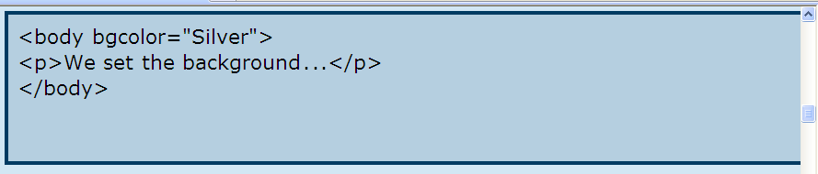
Hexadecimal colors
http://html-color-codes.com/
<font color =#CC0066>
Images
<img src = “stargif.gif”>

HTML HyperText Markup Language

- Creating a Simple Web Page using Notepad
There are many ways to create Web pages. Hundreds of companies have created tools to help with the process in one way or another. Our goal here, however, is to understand how Web pages really work, rather than have a tool hide the process from us. Therefore, we will use the simplest tools possible -- the ones already on your machine.
On your computer you have a program, or application that creates simple text files.
On Windows machines, this application is called Notepad. Open Notepad: right click on a Word document, and then tell it to open Notepad……to get to Notepad, create a NEW file in Notepad and following the following directions.
HTML
Open NOTEPAD, when typing HTML, you must include beginning <tags> and ending </tags>. The beginning <tag> tells the computer what to do and the ending tag </tag> tells the computer to stop doing what you asked. Every webpage includes the following tags and text. The title contains the title of your webpage that will show in the title bar of your web pages. The body of the html is where the information that you want to show on the web is placed.
<html>
<head>

<title> </title>
</head>
<body>

</body>
</html>
PART B-Type the following HTML
<html>
<head>
<title>My First Web Page</title>
</head>
<body>
Hello there. This is my first page!
</body>
</html>

Whether you put the tags and text side-by-side, row-by-row or indented will not make a difference in how the text is displayed in a browser window. Whether you use uppercase or lowercase letters within your tags also does not make a difference.
Now you need to save this file somewhere so that you can find it in a moment. Save it in your folder as first.html
It is very important to remember to save your file as first.html in your Webpage folder. If you do not add the .html your file will not work.
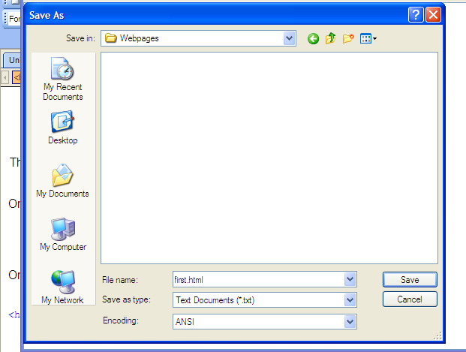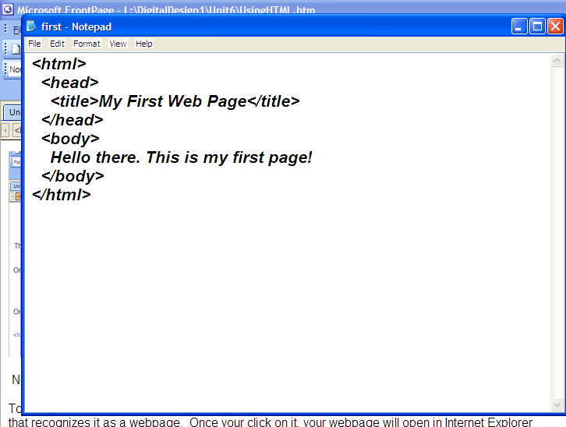
Next, minimize notepad. To view what your web page.
Open your web browser, click OPEN,
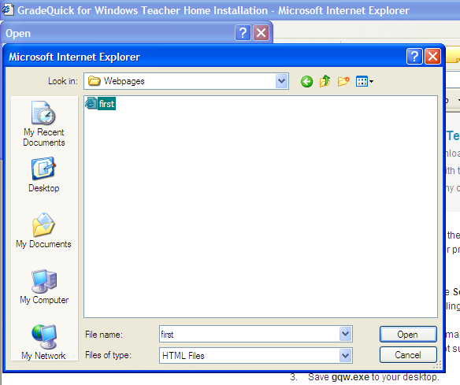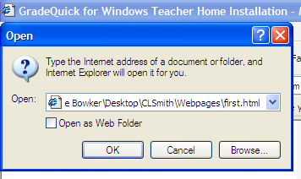
Go to your folder on the desktop, open your folder and click on the file named first.html
Click OK and your webpage will appear.
Three things are identified in this figure:
- You can see that the page has the title "My First Page."
- You can see that the page's body contains the words "Hello there. This is my first page!"
- You can see that the URL being displayed in the address window from your folder, rather than the usual http://... that a URL would contain if we were receiving the page from a server on the Internet.
By looking at the HTML text that makes up your first page, you can see exactly how the page got its title and body.
Now that you have created and viewed your first Web page, you are well on your way to becoming a Web page pro. The key to knowing everything about how a Web page works is to learn more and more of the HTML tags that let you customize your pages.

PART C
Now lets add some more basics to your first web page. Minimize your web browser and re-open your file first.html in notepad.
Make the following changes.
<html>
<head>
<title>My First Web Page</title>
</head>
<body>
<center><B>Hello there.</B><BR><BR>
<marquee><font color="red"><font face="Broadway BT">
<font size="7"> My name is </font></marquee><BR><BR>
<font color="blue"><I>This is my first page!</I>
</body>
</html>
Save your file when all your changes have been made.
Re-open your browser, click the refresh button on your toolbar and see your changes.
II. Creating webpages using Word
Open Word
Design a flyer for a car wash, yard sale etc.
File, Save as name of flyer, file type HTML
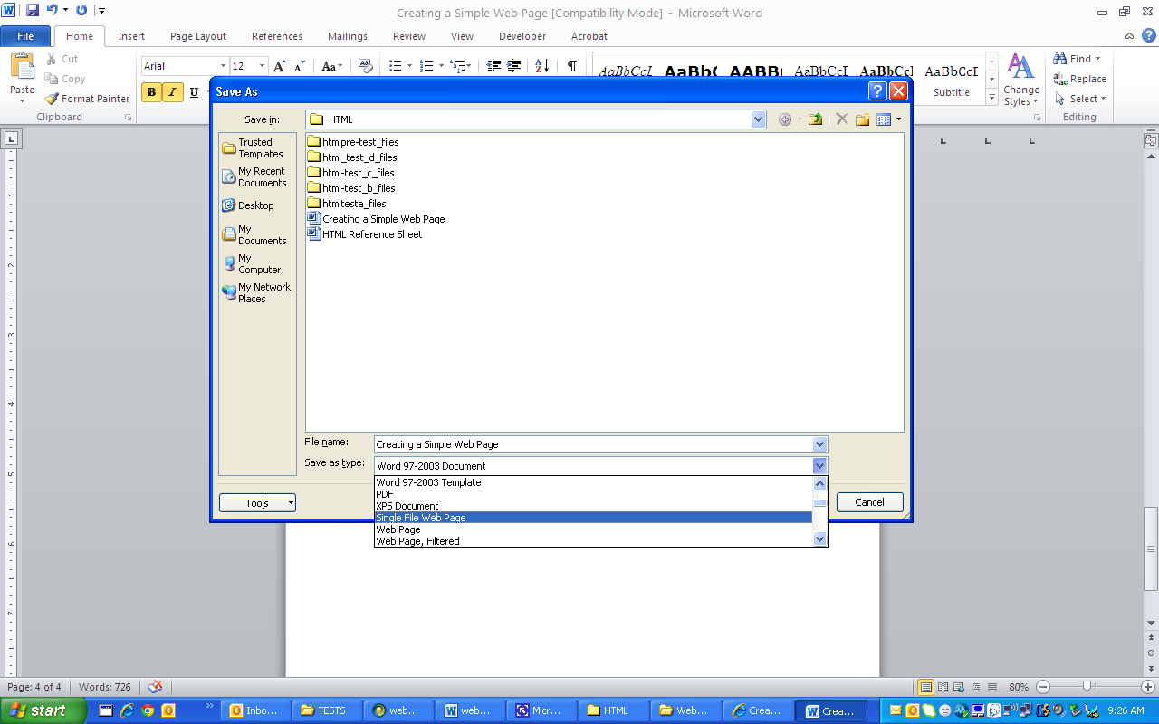
Close, go to your folder find the webpage you create and click on it. It will open in Internet Explorer.
On the webpage, choose View, Source and see the HTML code that the computer did for you.

- Creating Web pages in Microsoft FrontPage
Part A
Open Microsoft FrontPage, compare the tools with Microsoft Office 2010.
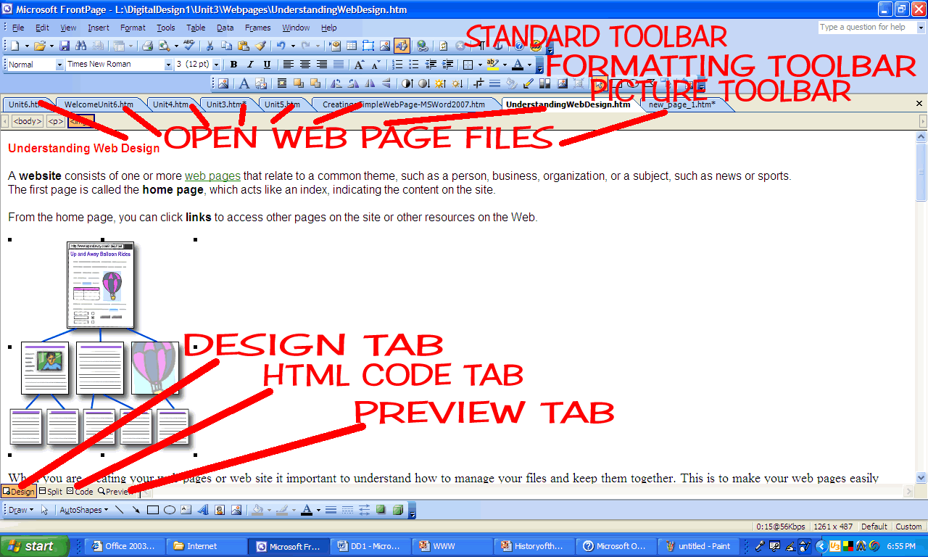
The design tab, html code tab, and the preview tab are designed for Microsoft FrontPage 2003 features. This program is very user friendly.
You will now create your web pages.
It is important to used tables when designing web pages, just like you did when you created web pages using Microsoft Office Word 2010.
Think about what links you want to create:
As you create a web page, you must change your page properties so that your title in web browser shows it is your web page and not new page 1. Right click, click page properties
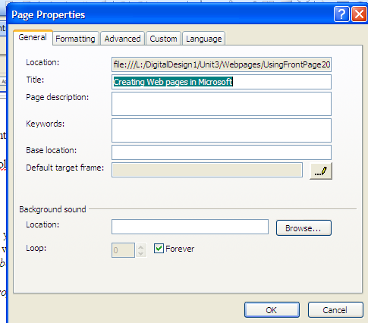
Under title, type your FirstName LastName Portfolio.
You can keep the same title on all your pages or create different titles for each webpage.
Note this is where you would add sounds and images to the background of your web pages as well.
Insert Table
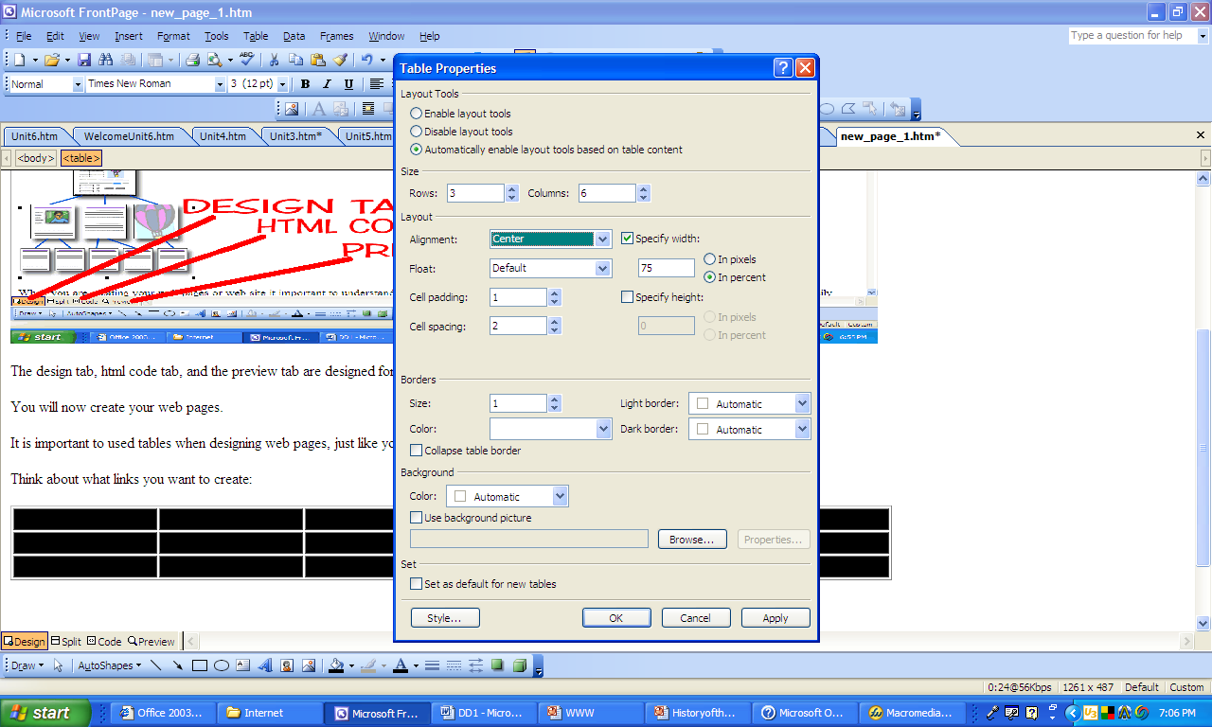Format table 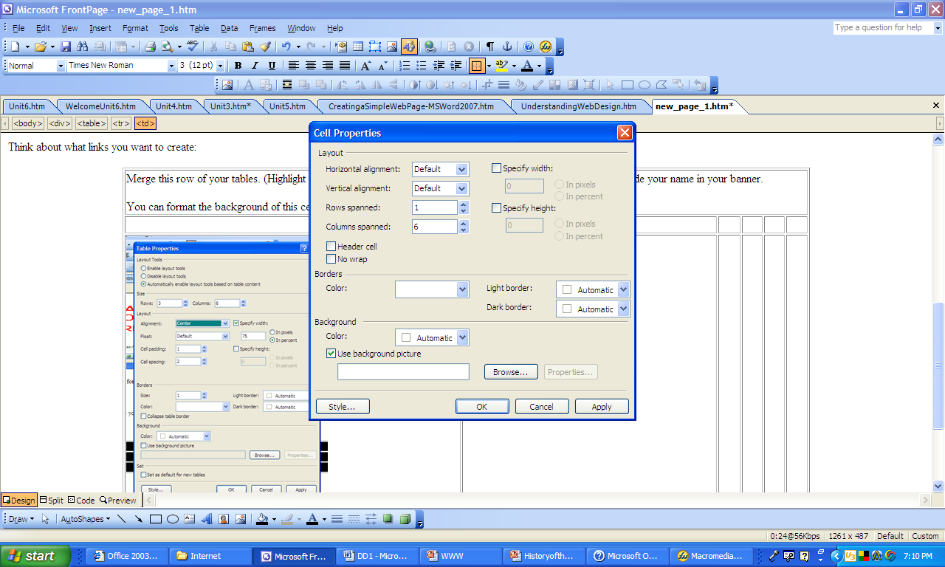
Merge rows and columns like below
INSERT ANIMATED BANNER
Home
Family
School
Goals
Career

You can change your border colors, by highlighting the table, right click, click on tables, and change borders. You can also highlight table and go to FORMAT borders and shadings.
Once your pages is created save it in your folder, lastnameportfolio and name it template.html. Just design it. Do not put any information in this page. SAVE
Part B
Open your template and create a web page for each of the items you listed in your table, such as home, family, schools, Goals, and Careers. Using the same layout of your template. You must create 5 web pages, including a index page that you will create, which is your home page, the name of the webpages must match the 5 items listed on your template web page. Save each one with the topic you are creating a web page for. Example home will be save as index.html, family will be save as family.html etc.
Part C
Creating hyperlinks within your web page. Once you have created all your web pages, only then should you link them.
Open all your pages you created. On the template, hyperlink Home, Family, School, Goals and Career.
You either highlight text right click and insert hyperlink, browsing your files and finding the web page you want to link to.
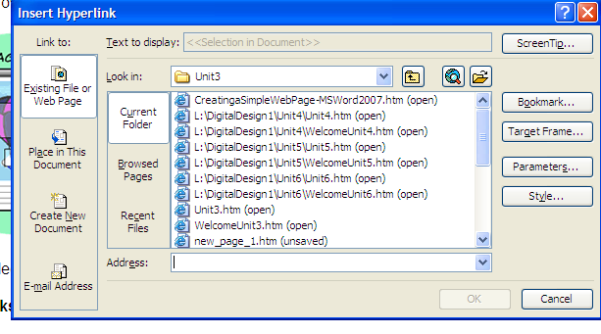
Then click on target frame and tell Microsoft FrontPage where you want to the web page to appear.
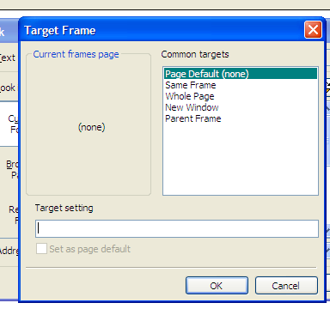
New Window- opens a smaller web browser window.

Whole Page-opens a new whole page web browser window.
Same Frame-opens the page in the current web browser window.
Parent Frame-opens the page in the parent web browser window.
Later we will be working with labeling frames and targeted them instead of the default common targets listed.

Copy those links in your table of contents or navigation bar, copy and paste to all your other pages. When pasting click in first cell, CTRL+V and it will paste them correctly.

SAVE YOUR FILE. Open your index page from your folder and test links within your portfolio.

